Actividad Formularios con StateFulWidgets

import 'package:flutter/material.dart';

void main() {
runApp(const MyApp());
}

class MyApp extends StatelessWidget {
const MyApp({super.key});

@override
Widget build(BuildContext context) {
return MaterialApp(
title: 'Registro Flutter',
theme: ThemeData(
primarySwatch: Colors.teal,
fontFamily: 'Raleway',
),
debugShowCheckedModeBanner: false,
home: const RegisterPage(title: 'Registro'),
);
}
}

enum SinginCharacter { femenino, masculino }

class RegisterPage extends StatefulWidget {
const RegisterPage({super.key, required this.title});
final String title;

@override
State<RegisterPage> createState() => _RegisterPageState();
}

class _RegisterPageState extends State<RegisterPage> {
SinginCharacter? _sex = SinginCharacter.femenino;
final _formKey = GlobalKey<FormState>();

final TextEditingController _nombreController = TextEditingController();
final TextEditingController _apellidoController = TextEditingController();
final TextEditingController _correoController = TextEditingController();
final TextEditingController _passwordController = TextEditingController();
final TextEditingController _confirmPasswordController = TextEditingController();

@override
void dispose() {
_nombreController.dispose();
_apellidoController.dispose();
_correoController.dispose();
_passwordController.dispose();
_confirmPasswordController.dispose();
super.dispose();
}

void limpiarCampos() {
_nombreController.clear();
_apellidoController.clear();
_correoController.clear();
_passwordController.clear();
_confirmPasswordController.clear();
setState(() {
_sex = SinginCharacter.femenino;
});
}

@override
Widget build(BuildContext context) {
return Scaffold(
backgroundColor: const Color(0xFF1E1E1E),
body: SingleChildScrollView(
child: Container(
margin: const EdgeInsets.only(top: 40, left: 30, right: 30),
child: Column(
crossAxisAlignment: CrossAxisAlignment.start,
children: <Widget>[
Container(
margin: const EdgeInsets.only(top: 20),
child: const Text(
'Registrarse',
style: TextStyle(
fontWeight: FontWeight.bold,
fontSize: 30,
color: Color(0xFFD2B48C)),
),
),
const Padding(
padding: EdgeInsets.symmetric(vertical: 10),
child: Text('¡Ya puedes registrarte, bienvenido!',
style: TextStyle(color: Color(0xFFB0B0B0))),
),
Form(
key: _formKey,
child: Column(
children: <Widget>[
Padding(
padding: const EdgeInsets.only(top: 30),
child: TextFormField(
controller: _nombreController,
decoration: InputDecoration(
hintText: 'Nombre',
hintStyle: const TextStyle(
fontWeight: FontWeight.w600,
color: Color(0xFFB0B0B0)),
fillColor: const Color(0xFF2C2C2C),
border: InputBorder.none,
filled: true,
),
style: const TextStyle(color: Colors.white),
validator: (value) {
if (value == null || value.isEmpty) {
return 'Por favor ingrese su nombre';
}
if (value.trim().length < 6) {
return 'El nombre debe tener al menos 6 caracteres';
}
return null;
},
),
),
Padding(
padding: const EdgeInsets.only(top: 15),
child: TextFormField(
controller: _apellidoController,
decoration: InputDecoration(
hintText: 'Apellidos',
hintStyle: const TextStyle(
fontWeight: FontWeight.w600,
color: Color(0xFFB0B0B0)),
fillColor: const Color(0xFF2C2C2C),
border: InputBorder.none,
filled: true,
),
style: const TextStyle(color: Colors.white),
validator: (value) {
if (value == null || value.isEmpty) {
return 'Por favor digite su apellido';
}
if (value.trim().length < 5) {
return 'El apellido debe tener al menos 5 caracteres';
}
return null;
},
),
),
Padding(
padding: const EdgeInsets.only(top: 15),
child: Row(
children: <Widget>[
Row(
children: [
Radio<SinginCharacter>(
value: SinginCharacter.femenino,
groupValue: _sex,
activeColor: const Color(0xFFD2B48C),
onChanged: (SinginCharacter? value) {
setState(() {
_sex = value;
});
},
),
const Text('Femenino',
style: TextStyle(color: Colors.white))
],
),
Row(
children: [
Radio<SinginCharacter>(
value: SinginCharacter.masculino,
groupValue: _sex,
activeColor: const Color(0xFFD2B48C),
onChanged: (SinginCharacter? value) {
setState(() {
_sex = value;
});
},
),
const Text('Masculino',
style: TextStyle(color: Colors.white))
],
),
],
),
),
Padding(
padding: const EdgeInsets.only(top: 15),
child: TextFormField(
controller: _correoController,
decoration: InputDecoration(
hintText: 'Correo',
hintStyle: const TextStyle(
fontWeight: FontWeight.w600,
color: Color(0xFFB0B0B0)),
fillColor: const Color(0xFF2C2C2C),
border: InputBorder.none,
filled: true,
),
style: const TextStyle(color: Colors.white),
validator: (value) {
if (value == null || value.isEmpty) {
return "El correo es necesario";
}
if (!value.contains('@')) {
return "Correo inválido: debe contener @";
}
return null;
},
),
),
Padding(
padding: const EdgeInsets.only(top: 15),
child: TextFormField(
controller: _passwordController,
obscureText: true,
decoration: InputDecoration(
hintText: 'Contraseña',
hintStyle: const TextStyle(
fontWeight: FontWeight.w600,
color: Color(0xFFB0B0B0)),
fillColor: const Color(0xFF2C2C2C),
border: InputBorder.none,
filled: true,
),
style: const TextStyle(color: Colors.white),
validator: (value) {
if (value == null || value.isEmpty) {
return "La contraseña es necesaria";
}
if (value.length < 10) {
return "La contraseña debe tener al menos 10 caracteres";
}
if (value.length > 20) {
return "La contraseña no puede tener más de 20 caracteres";
}
return null;
},
),
),
Padding(
padding: const EdgeInsets.only(top: 15),
child: TextFormField(
controller: _confirmPasswordController,
obscureText: true,
decoration: InputDecoration(
hintText: 'Confirmar contraseña',
hintStyle: const TextStyle(
fontWeight: FontWeight.w600,
color: Color(0xFFB0B0B0)),
fillColor: const Color(0xFF2C2C2C),
border: InputBorder.none,
filled: true,
),
style: const TextStyle(color: Colors.white),
validator: (value) {
if (value == null || value.isEmpty) {
return 'Por favor confirme la contraseña';
}
if (value.length < 10) {
return 'La contraseña debe tener al menos 10 caracteres';
}
if (value.length > 20) {
return 'La contraseña no puede tener más de 20 caracteres';
}
if (value != _passwordController.text) {
return 'Las contraseñas no coinciden';
}
return null;
},
),
),
const SizedBox(height: 30),
SizedBox(
width: double.infinity,
height: 45,
child: ElevatedButton(
onPressed: () {
if (_formKey.currentState!.validate()) {
ScaffoldMessenger.of(context).showSnackBar(
SnackBar(
content: Row(
mainAxisAlignment: MainAxisAlignment.start,
children: const <Widget>[
Icon(Icons.check_circle,
color: Colors.white),
SizedBox(width: 5),
Text("Usuario registrado correctamente",
style: TextStyle(color: Colors.white))
],
),
duration: const Duration(milliseconds: 2000),
width: 300,
padding: const EdgeInsets.symmetric(
horizontal: 8.0, vertical: 10),
behavior: SnackBarBehavior.floating,
shape: RoundedRectangleBorder(
borderRadius: BorderRadius.circular(3.0)),
backgroundColor: Color(0xFF388E3C),
),
);
}
},
style: ElevatedButton.styleFrom(
backgroundColor: const Color(0xFFD2B48C),
foregroundColor: Colors.black,
),
child: const Text('Registrarse'),
),
),
const SizedBox(height: 15),
SizedBox(
width: double.infinity,
height: 45,
child: ElevatedButton(
onPressed: limpiarCampos,
style: ElevatedButton.styleFrom(
backgroundColor: const Color(0xFFB0B0B0),
foregroundColor: Colors.black,
),
child: const Text('Limpiar formulario'),
),
),
],
),
)
],
),
),
),
);
}
}

Captura pidiendo validaciones
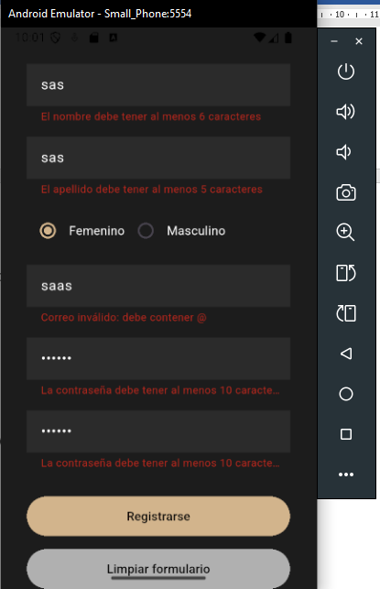
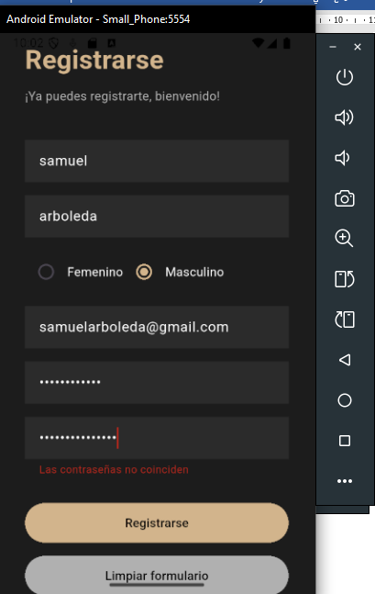

Validaciones correctas
